The Albourne Way

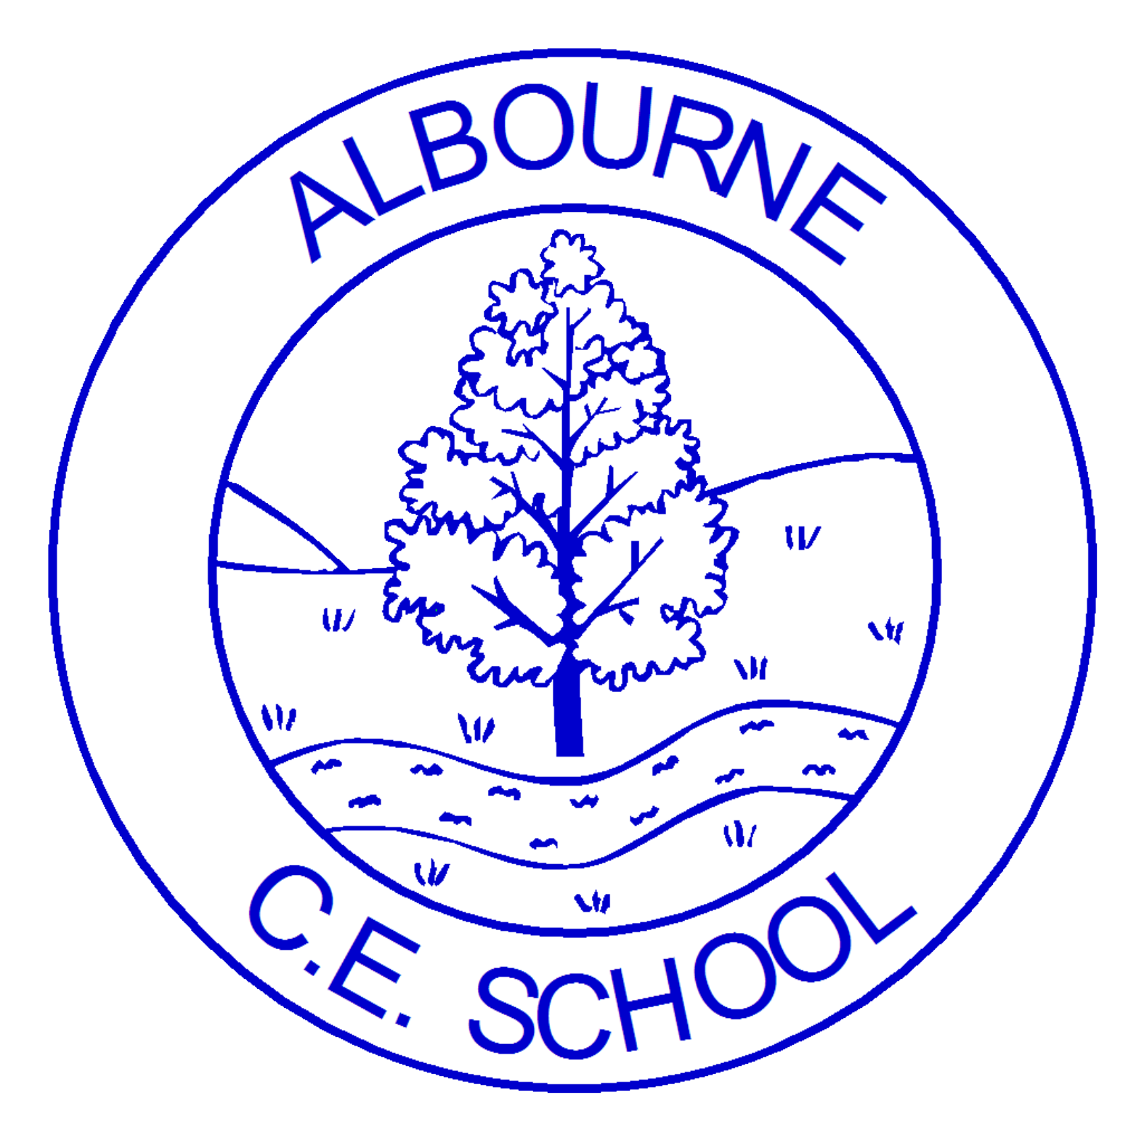

Living life to the full

ALBOURNE PRIMARY SCHOOL
WHOLE SCHOOL CURRICULUM MAP 2023-24

 | Autumn Term |  |  | Spring Term |  |  |  | Summer Term
 | Autumn 1 |  | Autumn 2 | Spring 1 |  | Spring 2 |  | Summer 1 | Summer 2
Christian Value / Bible Story | Perseverance  ‘Let us run with perseverance the race marked out for us.’ Hebrews 12: ‘Let us run with perseverance the race marked out for us.’ Hebrews 12:1  The Parable of the Lost Sheep Luke 15 |  | Respect  'Do to others as you would have them do to you.' (Matthew 7: 12)  Jesus’s Golden Rule John 13:34 | Aspiration  ‘Move from here to there,’ and it will move. Nothing will be impossible for you.  (Matthew 17:20)  House built on the rock of wisdom Matthew 7: 24-27 |  | Responsibility  ‘I can trust you. You have taken good care of a few things. I will put you in charge of many things.’ (Matthew 25:23)  Genesis 2:4-20 |  | Kindness  ‘Be kind and compassionate to one another, forgiving each other, just as in Christ God forgave you.’ (Ephesians 4:32)  The Good Samaritan Luke 10: 25-37 | Courage  Be on your guard; stand firm in the faith; be courageous; be strong. (1 Corinthians 16:13)  David and Goliath Samuel 1:7
British Values | Democracy  Being able to make choices |  | Tolerance of those of other faiths and beliefs  Tolerance and harmony between different cultural traditions | Rule of law  Distinguishing right from wrong |  | Mutual respect  All members of the school community should be treated with respect |  | Individual liberty  Taking responsibility for our own behaviour | Mutual respect  All members of the school community should be treated with respect
Flourish – live life to the full | House Captains  Pupil Parliament  Ambassadors Meeting  Diversity Ambassadors Coffee Morning  Peacekeepers Assembly  House Assemblies  Playground Party  Remembrance Day Community Event |  | Charity Event  Community Day  Parent/carer tours  Albourne Writers’ Awards  Albourne Readers’ Awards  Djembe performance  Singing Stars  Class Grow / Cook | Diversity Ambassadors Conference  International Women’s Event (parents…. |  | Community Day  Ukulele Performance  Albourne Writers’ Awards  Albourne Readers’ Awards  Class Grow / Cook  Mental Health Day Events |  | Paralympic Day | Community Day  Y6 Design & Sell  Cornet Performance  Hurst theatre  Albourne Writers’ Awards  Albourne Readers’ Awards  Class Grow / Cook
Preventative Curriculum / PSHE | Being me and my world  Trusted Adults  Mental Health |  | Celebrating differences (including Anti- bullying week)  Online Safety  Mental Health Day  Financial Safety | Dreams and goals  NSPCC Speak out Stay Safe |  | Healthy me  Online Safety  Mental Health Week |  | Relationships | Changing me  RSE  Online Safety
Religious Calendar links | Eid-ul-Adha  Harvest Festival  Yom Kippur |  | Diwali  Hannukkah  Advent  Christmas | Epiphany  Chinese New Year  St Valentine’s Day |  | Ash Wednesday  Lent and Easter  Mothers’ Day  Holi |  | Ascension  Ramadan | Eid al Fitr  Pentecost
Awareness weeks | International Day of Peace  World Food Day  Poetry day  International Day of Democracy  World Mental Health Day, European day of languages |  | Remembrance Day Anti-Bullying Week – Choose Respect  Road Safety Week  Children in Need  Black History Month- Oct  International Day- Abolition of slavery  Guy Fawkes, UK Parliament week, Diwali, International day of disabled persons, Human Rights Day, St Nicholas, Christmas | Storytelling week  UNCIEF Day for Change  Safer internet Day  Martin Luther King Day  World Religion Day, Children’s mental health week |  | World Water Day  Red Nose Day  World Book Day  Women’s History Month  Autism Awareness  St George’s Day  International Languages  Woman’s History month, International Women’s Day, Neurodiversity week, World Book Day, Ramadan, Easter |  | Walking to School Child Safety Week  World Earth Day  Ramadan & Eid-al-fitr, World Environment Day, VE Day | World Ocean Day  Sussex Day-16th June  Happiness World Refugee Day, International Day of Friendship, LGBTQ+ month, Roma/traveler month
Parental Links | Meet the teacher  Home visits for new Yr R Phonics Workshop  Albourne Family Forum  Open classroom  EYFS 6 weeks in Meeting  Harvest Festival |  | Parents’ Evening Christmas Nativity  Open classroom  Christmas Fair  Writing Workshop | Parents’ Evening  Safer internet workshops  Open classroom  Maths Workshop  Albourne Family Forum |  | Easter Church Service  Open classroom  Reading Workshop |  | Open classroom  Albourne Family Forum  Art Exhibition | Transition  New chn/parents Stay n Plays  Leaver’s Church Service  Reports  Sports’ Day  Summer Fair
EYFS  Robins | All About Me  What makes me unique? |  | Toys!  How have toys changed over time? | Stomp, Chomp, Roar! (Dinosaurs)  What would we see if we could travel back in time? |  | Once Upon a Time  What stories can you retell? |  | All Creatures Great & Small
 |  |  |  |  |  |  |  | Under the Sea  Why are the oceans so important? | Mini-beasts  How do creatures change?
Trips & Experiences | Albourne Welly Walks |  | Museum Loan – retro toys  Nativity  Harvest  Panto Rainbow Theatre | Museum Loan Box: (fossils and bones)  Albourne Welly Walks  Theatre trip |  | Albourne Welly Walks  Traditional Tale Ball |  | Albourne Welly Walks  Under the Sea/Pirates and Mermaids Day | Albourne Welly Walks  Blackberry Farm
Year 1  Wagtails | Once Upon a Time in Albourne  What is Albourne like now?  What was it like in the past? |  |  | A Trip to London  What is London like? |  | Great Fire of London  What happened during the Great Fire of London? |  | Our Natural World  How do things change in each season?
Trips &  Experiences | Albourne Walk |  |  | Horsham Museum Loan Box (Victorian school)  Nativity |  | Great Fire of London Workshop |  | Wakehurst Place
Year 2  Skylarks | Castles and Dragons  How did all these castles get here? |  |  | Our Amazing Earth  What makes our Earth so special? |  | Australia here we come  Would you like to visit Australia? |  | Space  What happens if you keep going up?
Trips &  Experiences | Arundel Castle |  |  | Nativity |  | Australia Day |  | Science Museum
Year 3 | Stone Age to Iron Age  What did the Stone Age do for us? |  |  | Ancient Egypt  Who were the Ancient Egyptians? |  |  |  | Our Island: UK and South Downs  What makes our Island special?
Trips &  Experiences | Butser Farm |  |  | Cuckfield Museum Loan Box (Stone Age to Iron Age) | Egyptians- Portals to the Past |  |  | Cuckmere Haven |  | Park Ranger
Year 4/5 | Earthquakes, Volcanoes and Mountains (Europe)  Why do some earthquakes cause more damage than others? How do volcanoes effect the lives of the people of Hiemaey? How are the Cambrian mountains different from the Himalayan mountains? |  |  | World War 2  Why was the Battle of Britain in 1940 so important?  What was the war like for people where I live? |  |  |  | Fair Trade  Why is Fair Trade fair?
Trips &  Experiences | Geocoaching  Natural History Museum |  | Build a boat-STEM Challenge | WW2 Theatre | Newhaven Fort  Cuckfield Museum Loan Box: (WW2) |  |  | Residential
Year 5/6 | Earthquakes, Volcanoes and Mountains (Europe)  Why do some earthquakes cause more damage than others? How do volcanoes effect the lives of the people of Hiemaey? How are the Cambrian mountains different from the Himalayan mountains? |  |  | World War 2  Local focus:  What was the war like for people in local our area? How did it change their lives? Where were defences built and why?  Wider focus:  What were the main reasons for the second world war? What was an evacuee? How did the role for women change in WW2? What jobs were women expected to do? What was the holocaust? Why did the holocaust happen? |  |  |  | Fair Trade  Why is Fair Trade fair?
Trips &  Experiences  Year 6 only | Natural History Museum | Build a boat-STEM Challenge |  | WW2 Theatre |  |  | Newhaven Fort  Cuckfield Museum Loan Box: (WW2) | Residential

