Ask Me About
Kestrels 2023-2024
March 2024
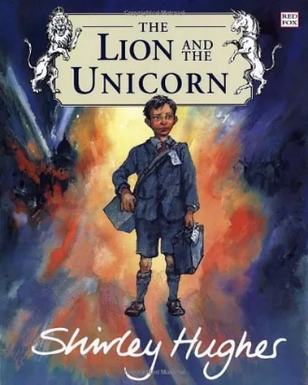
English
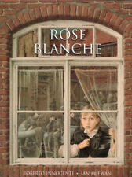
The children have produced some wonderful poetry at the end of their topic work on WW2-based around the personification of War and having read/watched poems and protest songs. They have also continued to produce some strong narrative/retell work, using: Rose Blanche, diary work (based around their understanding of life as an evacuee) and formal and informal letters (based around the Lion and the Unicorn).
Maths
We have covered the areas of measurements, exploring how we use them in everyday life (mass, capacity, time and length). We have also recapped the children’s understanding of 2D and 3D shape; developing an understanding of volume and nets. The shape work linked to our work on angles in triangles, straight lines, quadrilaterals and full circles. We have continued assessing arithmetic skills and giving small group/individual support to children needing reminders of methods. We have identified times tables as still being a weakness for a group of children and will be addressing this with opportunities for them to practise their skills in short sessions. Mrs Atkins is continuing to work with a small group of children to develop targeted areas of their maths topic work covered in class. Assessments have been carried out and helped us identify children who are not yet secure with the expected maths understanding. We will continue to support these children in class and with small group interventions.
Reading
We have continued reading ‘Goodnight, Mr. Tom’- the children have been wrapped up in the unfolding drama for Will and Tom. As ever, encourage your children to read every day and across a range of genres and styles- open up their minds to the amazing books which are available, either by purchase, through libraries (including the class one) or online. Assessments have shown a good improvement with comprehension skills by the children; Mrs. Henson will be still working with some children to develop fluency, but will also have a group targeted with developing their comprehension skills.
Other Subjects
World War Two has been our topic focus, this term we explored the roles of women and the story of the Kinder transport-we were all fascinated to find one of the pupils had a family link to the Kinder transport, which they very kindly shared with the class. It has been a hard topic at times, based on its nature and with the current events in the world, but the children have shown a wise and compassionate understanding.
This term, we asked the question, ‘What difference does the resurrection make to Christians?’ offering children the opportunity to explore the importance of a belief in the resurrection to the Christian faith. We explored this through what historians know about Christ, what Christians believe and what other faiths and non-believers might say.
We have moved onto exploring the coding of variables in computing, using Espresso.
In Science we have found out about the importance of blood and how it circulates around our body, spreading oxygen and nutrients.
PE has been interrupted by other events and the weather, but we have had some opportunities to look at basic tennis and gymnastic skills.
Art has been a great success- art week allowed the children to explore landscape based around ordnance survey maps- hopefully, you got to attend the exhibition showcasing their skills. Thanks also to Blake’s dad for sharing his creative and photography work. In DT the children have been making cam operated models.
We have continued with French lessons with the aid of the language specialist from Hurst. PSHE work was based on ‘Healthy Me’: helping the children to discover about the peer pressure applied by gangs.
Homework
Homework is on Google Classroom and will be available as a paper copy for those who prefer it. So far, the majority of children have made every effort to complete their homework on time- please keep this up. Please remind them, that if they need help to ask for class support (during the week the homework has been set).
SATs
Next term the children will face their SATs exams. It is really important that the children keep revising using the given revision books. They also have a link to https://www.maths.co.uk/ in which I will set practice tasks for them to complete. It will mark and show any errors, so they can try to learn from their mistakes. Please, remind the children to come and speak to myself or Mrs. Henson should they need help.

Miscellaneous
- If you have any concerns about the children and their use of social media, can you please use the links on the school website (key information/e-safety advice)
- Can you please make sure that all children wear appropriate PE kit in school for their PE days (Tuesday and Thursday)
- If you need to speak with myself or Mrs Henson please contact the school and we will arrange a suitable time.
- Miss. Beaton has now left to resume her studies- she was a great success and the children enjoyed having her teach them. We wish her every success with her future.
- By the time you read this, the children should know what their end of year performance will be. Please support them in learning their lines, songs and dances once the rehearsals begin.
- Wishing everyone a happy and peaceful Easter.
Mr. Hamilton and Mrs. Henson.

